Elite snow making capacity, total number of chairs, fast quads, total number of runs, the length of the runs, and skiable terrain area coupled with above average elevation drop set Big Mountain Ski Resort apart from our peers. Next season these features are expected to draw in 350,000 people who will each ski for five days on average. Ticket sales at the current ticket price of $81.00 are expected to generate 141.75 million dollars next season.

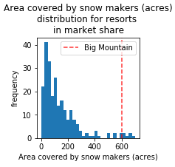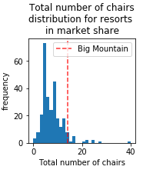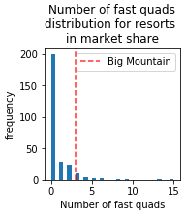

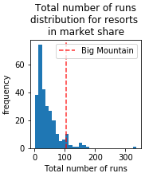 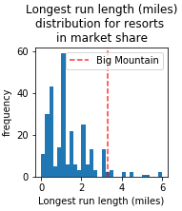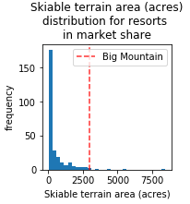

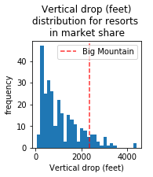 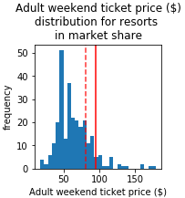

**____** current price

- - - - modeled price

The model suggests that the outstanding features at Big Mountain Ski Resort could command a ticket price of $94.22. Even considering the mean absolute error of $ 10.39, this model indicates there is room for a price increase. Setting the ticket price to $94.22 would result in an additional 23.135 million dollars of revenue next season, assuming that the change in price does not affect the projected number of tickets sold.

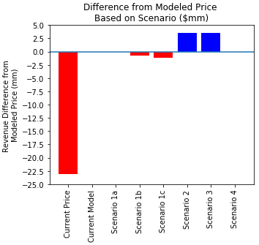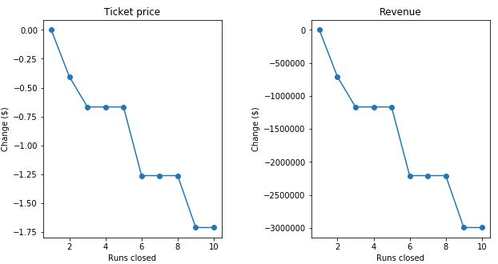Additionally, the model suggests that closing down a run (scenario 1a) would not affect the modeled price and closing down two runs (scenario 1b) would be a cause for a lower price. While closing a third run also decreases the modeled price, closing down four or five runs (scenario 1c) all result in the same modeled price as closing three runs.

Adding 150 feet of vertical drop and a new chair lift to service the resulting run (scenario 2) are expected to provide a price uplift of an additional $1.99 to the current modeled price. This would bring the total price to $96.20. Adding two acres of snow making capability to service this run (scenario 3) would likely not justify any additional price increase however.

Finally, increasing the distance of the longest run by 0.2 miles and adding four acres of snow making to service it (scenario 4) does not justify any increase in the modeled price.

